**Tensorflow環境需求：**

<https://www.tensorflow.org/install/gpu>

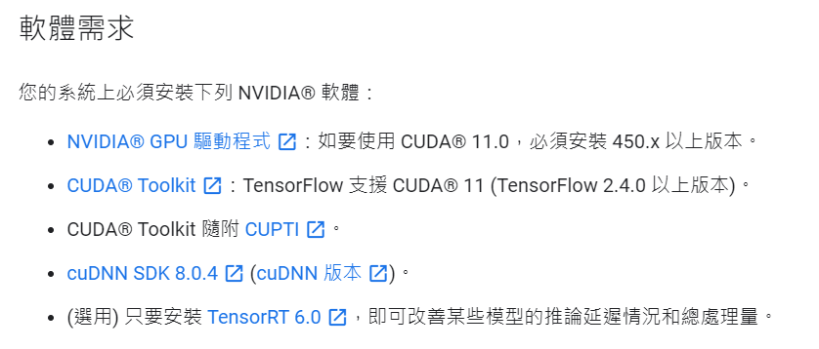

**步驟1：確認GPU硬體與driver資訊 ( 透過Nvidia control panel )**



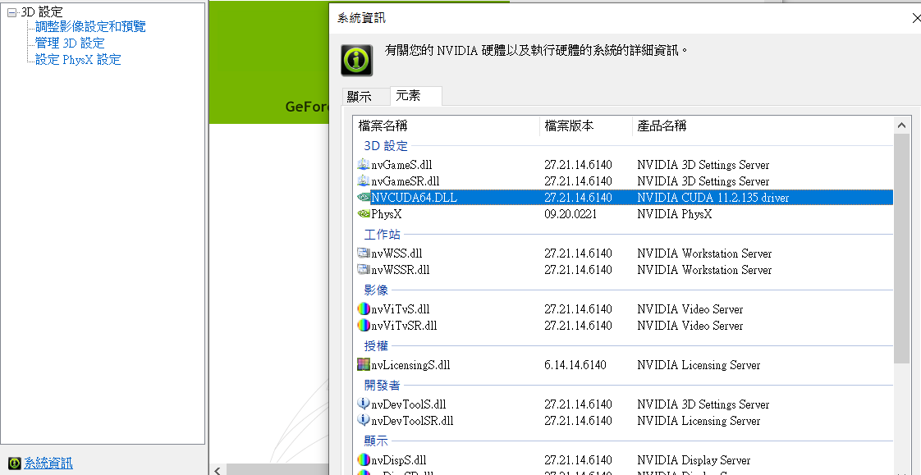

**步驟2：安裝C++開發環境，用於編寫CUDA程式碼 (可跳過)**

**Microsoft Visual Studio - Community version**

<https://visualstudio.microsoft.com/zh-hant/downloads/>



**VS 2019自帶git和Python, 可視需求使用**

**除了VS，也可以選擇Mingw (參考：<https://zhuanlan.zhihu.com/p/85231502> )**

**步驟3：CUDA安裝與CUDNN加速器使用，之後再安裝tensorflow-gpu**

**方案1： 利用Anaconda安裝，參考：**

<https://medium.com/analytics-vidhya/install-tensorflow-gpu-2-4-0-with-cuda-11-0-and-cudnn-8-using-anaconda-8c6472c9653f>

**建立虛擬環境後，依序使用以下指令：**

conda install -c anaconda cudatoolkit

conda install -c anaconda cudnn

**pip install tensorflow-gpu**

**可利用 conda search <pkgname> 確認可安裝的版號**

(tf-gpu-env-01) C:\Users\wind_>conda search cudatoolkit

Loading channels: done

# Name Version Build Channel

cudatoolkit 8.0 4 pkgs/main

cudatoolkit 9.0 1 pkgs/main

cudatoolkit 9.2 0 pkgs/main

cudatoolkit 10.0.130 0 pkgs/main

cudatoolkit 10.1.168 0 pkgs/main

cudatoolkit 10.1.243 h74a9793_0 pkgs/main

cudatoolkit 10.2.89 h74a9793_0 pkgs/main

cudatoolkit 10.2.89 h74a9793_1 pkgs/main

cudatoolkit 11.0.221 h74a9793_0 pkgs/main

(tf-gpu-env-01) C:\Users\wind_>conda search cudnn

Loading channels: done

# Name Version Build Channel

cudnn 7.1.4 cuda8.0_0 pkgs/main

cudnn 7.1.4 cuda9.0_0 pkgs/main

cudnn 7.3.1 cuda10.0_0 pkgs/main

cudnn 7.3.1 cuda9.0_0 pkgs/main

cudnn 7.6.0 cuda10.0_0 pkgs/main

cudnn 7.6.0 cuda10.1_0 pkgs/main

cudnn 7.6.0 cuda9.0_0 pkgs/main

cudnn 7.6.4 cuda10.0_0 pkgs/main

cudnn 7.6.4 cuda10.1_0 pkgs/main

cudnn 7.6.4 cuda9.0_0 pkgs/main

cudnn 7.6.5 cuda10.0_0 pkgs/main

cudnn 7.6.5 cuda10.1_0 pkgs/main

cudnn 7.6.5 cuda10.2_0 pkgs/main

cudnn 7.6.5 cuda9.0_0 pkgs/main

cudnn 7.6.5 cuda9.2_0 pkgs/main

**透過conda下載的版本會較舊，對新型GPU(例如RTX30系列)支援不一定達到最佳化**

(tf-gpu-env-01) C:\Users\wind_>conda list cuda

# Name Version Build Channel

cudatoolkit 10.2.89 h74a9793_1 anaconda

(tf-gpu-env-01) C:\Users\wind_>conda list cudnn

# Name Version Build Channel

cudnn 7.6.5 cuda10.2_0 anaconda

**路徑會位於 <anaconda3-path> / envs / <env-name> / pkgs 內，其中<anaconda3-path>是Anaconda建立的資料夾路徑，**

**<env-name> 是自定義虛擬環境的名稱。**

**透過 pip install 下載 tensorflow-gpu，目前可下載到的最新穩定版本是2.4.1**

**要注意此方案建立的CUDA僅能在此虛擬環境中使用，因其檔案很大，故針對個別虛擬環境安裝會很吃硬體空間。另外，在安裝過程中版本可能會有升降版的變化**

**安裝之後，需重新開機，再進行以下測試 (使用ipython)**

In [1]: import tensorflow as tf

2021-04-12 10:56:03.217549: I tensorflow/stream_executor/platform/default/dso_loader.cc:49] Successfully opened dynamic library cudart64_110.dll

In [2]: tf.test.is_gpu_available()

WARNING:tensorflow:From <ipython-input-2-17bb7203622b>:1: is_gpu_available (from tensorflow.python.framework.test_util) is deprecated and will be removed in a future version.

Instructions for updating:

Use `tf.config.list_physical_devices('GPU')` instead.

2021-04-12 10:58:29.524304: I tensorflow/core/platform/cpu_feature_guard.cc:142] This TensorFlow binary is optimized with oneAPI Deep Neural Network Library (oneDNN) to use the following CPU instructions in performance-critical operations: AVX2

To enable them in other operations, rebuild TensorFlow with the appropriate compiler flags.

2021-04-12 10:58:29.527636: I tensorflow/stream_executor/platform/default/dso_loader.cc:49] Successfully opened dynamic library nvcuda.dll

2021-04-12 10:58:30.927136: I tensorflow/core/common_runtime/gpu/gpu_device.cc:1720] Found device 0 with properties:

pciBusID: 0000:01:00.0 name: GeForce RTX 3070 Laptop GPU computeCapability: 8.6

coreClock: 1.29GHz coreCount: 40 deviceMemorySize: 8.00GiB deviceMemoryBandwidth: 357.69GiB/s

2021-04-12 10:58:30.927490: I tensorflow/stream_executor/platform/default/dso_loader.cc:49] Successfully opened dynamic library cudart64_110.dll

2021-04-12 10:58:34.164191: I tensorflow/stream_executor/platform/default/dso_loader.cc:49] Successfully opened dynamic library cublas64_11.dll

2021-04-12 10:58:34.164322: I tensorflow/stream_executor/platform/default/dso_loader.cc:49] Successfully opened dynamic library cublasLt64_11.dll

2021-04-12 10:58:34.192781: I tensorflow/stream_executor/platform/default/dso_loader.cc:49] Successfully opened dynamic library cufft64_10.dll

2021-04-12 10:58:34.198665: I tensorflow/stream_executor/platform/default/dso_loader.cc:49] Successfully opened dynamic library curand64_10.dll

2021-04-12 10:58:34.228518: I tensorflow/stream_executor/platform/default/dso_loader.cc:49] Successfully opened dynamic library cusolver64_10.dll

2021-04-12 10:58:35.540870: I tensorflow/stream_executor/platform/default/dso_loader.cc:49] Successfully opened dynamic library cusparse64_11.dll

2021-04-12 10:58:35.664535: I tensorflow/stream_executor/platform/default/dso_loader.cc:49] Successfully opened dynamic library cudnn64_8.dll

2021-04-12 10:58:35.664770: I tensorflow/core/common_runtime/gpu/gpu_device.cc:1862] Adding visible gpu devices: 0

2021-04-12 10:58:36.651908: I tensorflow/core/common_runtime/gpu/gpu_device.cc:1261] Device interconnect StreamExecutor with strength 1 edge matrix:

2021-04-12 10:58:36.652084: I tensorflow/core/common_runtime/gpu/gpu_device.cc:1267] 0

2021-04-12 10:58:36.653135: I tensorflow/core/common_runtime/gpu/gpu_device.cc:1280] 0: N

2021-04-12 10:58:36.654656: I tensorflow/core/common_runtime/gpu/gpu_device.cc:1406] Created TensorFlow device (/device:GPU:0 with 6606 MB memory) -> physical GPU (device: 0, name: GeForce RTX 3070 Laptop GPU, pci bus id: 0000:01:00.0, compute capability: 8.6)

2021-04-12 10:58:36.656557: I tensorflow/compiler/jit/xla_gpu_device.cc:99] Not creating XLA devices, tf_xla_enable_xla_devices not set

Out[2]: True

Unhandled exception in event loop:

File "C:\Users\wind_\anaconda3\envs\tf-gpu-env-01\lib\asyncio\proactor_events.py", line 768, in _loop_self_reading

f.result() # may raise

File "C:\Users\wind_\anaconda3\envs\tf-gpu-env-01\lib\asyncio\windows_events.py", line 808, in _poll

value = callback(transferred, key, ov)

File "C:\Users\wind_\anaconda3\envs\tf-gpu-env-01\lib\asyncio\windows_events.py", line 457, in finish_recv

raise ConnectionResetError(*exc.args)

**方案2： 手動下載**

**透過全域安裝搭配環境變數設定，可以避免個別安裝造成的硬體空間消耗，但缺點是各虛擬環境使用相同的CUDA版本(如不想使用該版本，可再虛擬環境中額外安裝cudatoolkit, 參考方案1)**

**CUDA下載連結如下，須注意與GPU Driver的版號對應**

<https://developer.nvidia.com/cuda-downloads?target_os=Windows&target_arch=x86_64&target_version=10&target_type=exelocal>

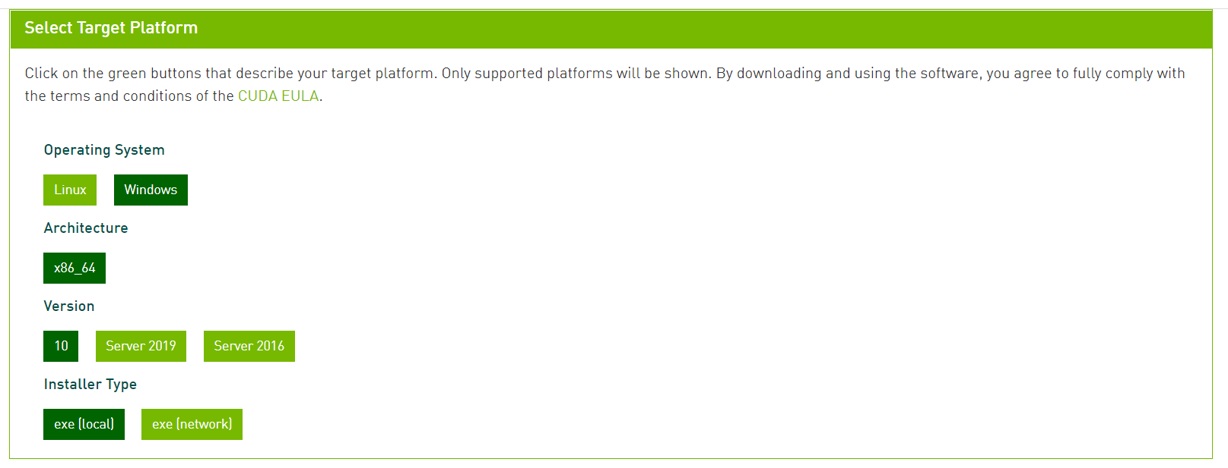

<https://docs.nvidia.com/deploy/cuda-compatibility/index.html>

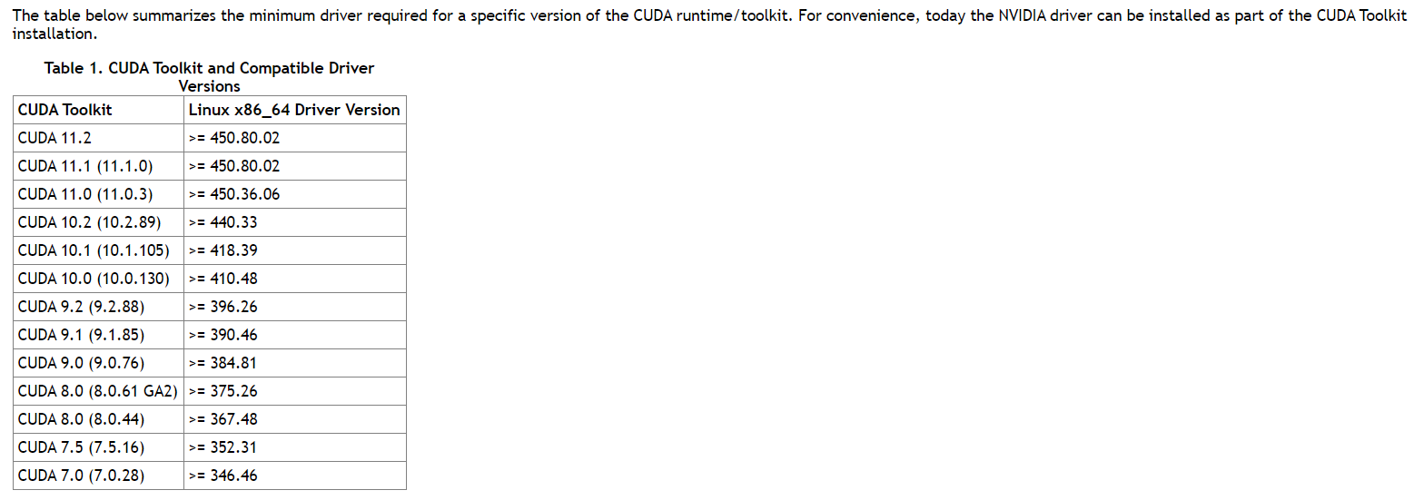

**CUDNN須注意與CUDA的版號對應**

<https://developer.nvidia.com/cudnn>

**需要註冊一個帳號，填寫相關問卷後才可下載檔案，同時會看到CuDNN列表**

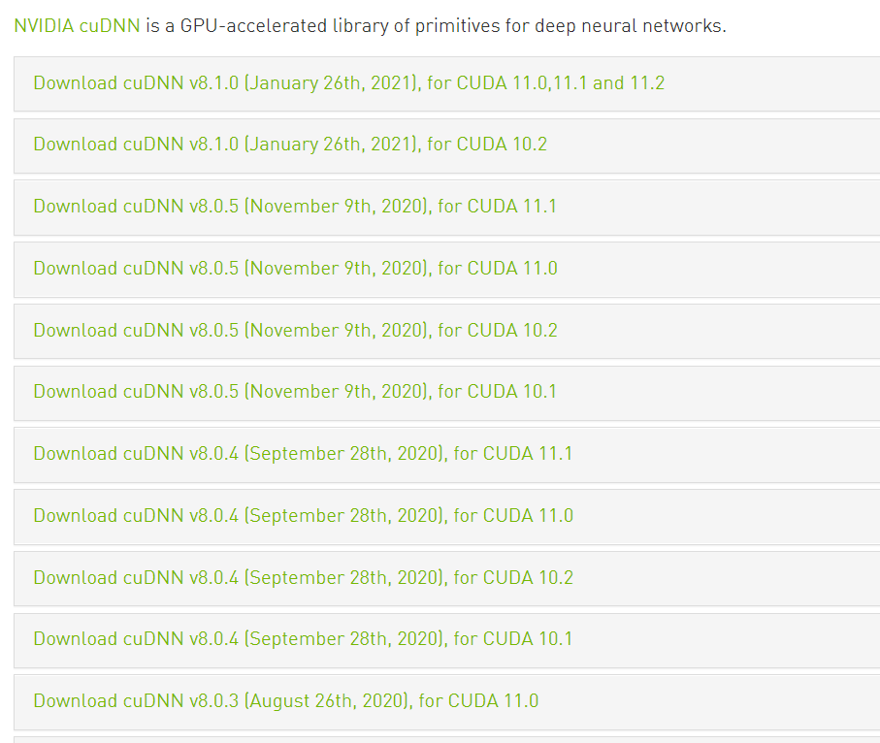

**手動安裝過程可參考**

<https://medium.com/ching-i/win10-%E5%AE%89%E8%A3%9D-cuda-cudnn-%E6%95%99%E5%AD%B8-c617b3b76deb>

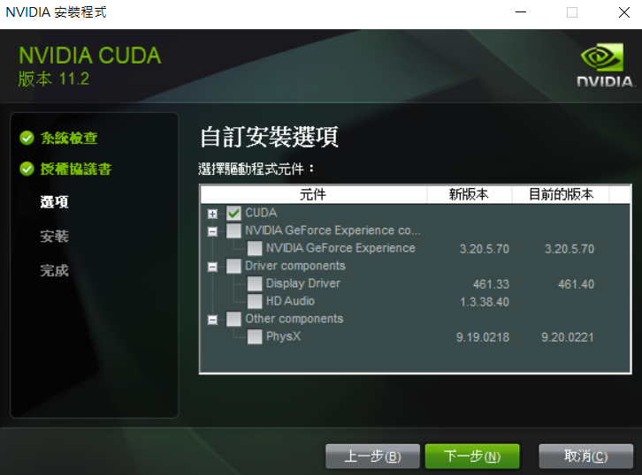

**新版本CUDA會確認設置路徑。使用默認，然後參考以下資訊：**

<https://www.tensorflow.org/install/gpu>

**CUDA安裝完成後，做以下檢查：**

* **命令提示字元下，nvcc -V 確認相關資訊**
* **本機→進階系統設定→環境變數**

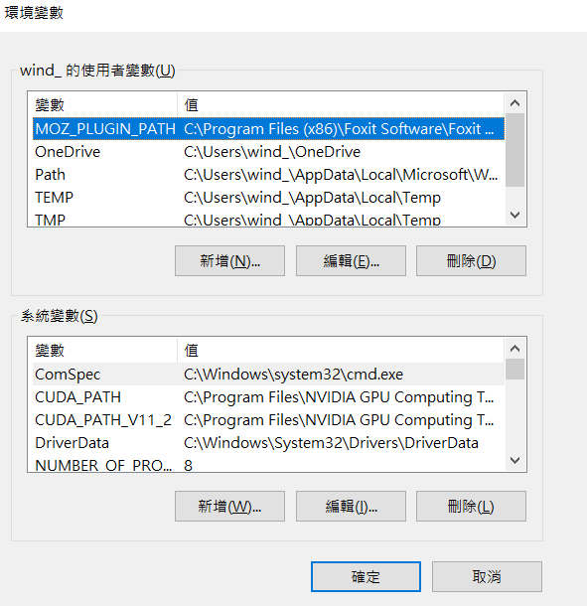

**CuDNN的安裝參考上述網誌或以下官方文件**

<https://docs.nvidia.com/deeplearning/cudnn/install-guide/index.html#install-windows>

**要做三件事情：其中<installpath>指的是CUDNN的路徑**

**- Copy <installpath>\cuda\bin\cudnn*.dll to C:\Program Files\NVIDIA GPU Computing Toolkit\CUDA\vx.x\bin.**

**- Copy <installpath>\cuda\include\cudnn*.h to C:\Program Files\NVIDIA GPU Computing Toolkit\CUDA\vx.x\include.**

**- Copy <installpath>\cuda\lib\x64\cudnn*.lib to C:\Program Files\NVIDIA GPU Computing Toolkit\CUDA\vx.x\lib\x64.**

**確認pip版本在19.0以上且python在3.8，先安裝tensorflow-gpu 2.4.0版，保留日後升版的變化**

(tf-gpu-env-02) C:\Users\wind_>pip3 --version

pip 20.2.4 from C:\Users\wind_\anaconda3\envs\tf-gpu-env-02\lib\site-packages\pip (python 3.8)

(tf-gpu-env-02) C:\Users\wind_>pip --version

pip 20.2.4 from C:\Users\wind_\anaconda3\envs\tf-gpu-env-02\lib\site-packages\pip (python 3.8)

(tf-gpu-env-02) C:\Users\wind_>python3 --version

(tf-gpu-env-02) C:\Users\wind_>python --version

Python 3.8.5

**如欲確認虛擬環境下是否可得知GPU資訊：**

(tf-gpu-env-02) C:\Users\wind_>nvidia-smi

**安裝tensorflow-gpu，並指定版本**

(tf-gpu-env-02) C:\Users\wind_>pip install tensorflow-gpu==2.4.0

**安裝成功之後，執行ipython後匯入tensorflow模組得到以下訊息**

In [1]: import tensorflow as tf

2021-04-12 10:40:57.345927: W tensorflow/stream_executor/platform/default/dso_loader.cc:60] Could not load dynamic library 'cudart64_110.dll'; dlerror: cudart64_110.dll not found

2021-04-12 10:40:57.346355: I tensorflow/stream_executor/cuda/cudart_stub.cc:29] Ignore above cudart dlerror if you do not have a GPU set up on your machine.

**重新開機(不一定必要)之後可解決以上問題，但還有錯誤待解**

(C:\Users\wind_\anaconda3) C:\Users\wind_>conda activate tf-gpu-env-02

(tf-gpu-env-02) C:\Users\wind_>ipython

Python 3.8.5 (default, Sep 3 2020, 21:29:08) [MSC v.1916 64 bit (AMD64)]

Type 'copyright', 'credits' or 'license' for more information

IPython 7.19.0 -- An enhanced Interactive Python. Type '?' for help.

In [1]: import tensorflow as tf

2021-04-12 11:02:52.230782: I tensorflow/stream_executor/platform/default/dso_loader.cc:49] Successfully opened dynamic library cudart64_110.dll

In [2]: tf.test.is_gpu_available()

WARNING:tensorflow:From <ipython-input-2-17bb7203622b>:1: is_gpu_available (from tensorflow.python.framework.test_util) is deprecated and will be removed in a future version.

Instructions for updating:

Use `tf.config.list_physical_devices('GPU')` instead.

2021-04-12 11:03:00.418946: I tensorflow/core/platform/cpu_feature_guard.cc:142] This TensorFlow binary is optimized with oneAPI Deep Neural Network Library (oneDNN) to use the following CPU instructions in performance-critical operations: AVX2

To enable them in other operations, rebuild TensorFlow with the appropriate compiler flags.

2021-04-12 11:03:00.422559: I tensorflow/stream_executor/platform/default/dso_loader.cc:49] Successfully opened dynamic library nvcuda.dll

2021-04-12 11:03:01.809235: I tensorflow/core/common_runtime/gpu/gpu_device.cc:1720] Found device 0 with properties:

pciBusID: 0000:01:00.0 name: GeForce RTX 3070 Laptop GPU computeCapability: 8.6

coreClock: 1.29GHz coreCount: 40 deviceMemorySize: 8.00GiB deviceMemoryBandwidth: 357.69GiB/s

2021-04-12 11:03:01.809721: I tensorflow/stream_executor/platform/default/dso_loader.cc:49] Successfully opened dynamic library cudart64_110.dll

2021-04-12 11:03:01.818666: I tensorflow/stream_executor/platform/default/dso_loader.cc:49] Successfully opened dynamic library cublas64_11.dll

2021-04-12 11:03:01.819391: I tensorflow/stream_executor/platform/default/dso_loader.cc:49] Successfully opened dynamic library cublasLt64_11.dll

2021-04-12 11:03:04.477374: I tensorflow/stream_executor/platform/default/dso_loader.cc:49] Successfully opened dynamic library cufft64_10.dll

2021-04-12 11:03:04.907360: I tensorflow/stream_executor/platform/default/dso_loader.cc:49] Successfully opened dynamic library curand64_10.dll

2021-04-12 11:03:04.908091: W tensorflow/stream_executor/platform/default/dso_loader.cc:60] Could not load dynamic library 'cusolver64_10.dll'; dlerror: cusolver64_10.dll not found

2021-04-12 11:03:04.912461: I tensorflow/stream_executor/platform/default/dso_loader.cc:49] Successfully opened dynamic library cusparse64_11.dll

2021-04-12 11:03:04.913802: I tensorflow/stream_executor/platform/default/dso_loader.cc:49] Successfully opened dynamic library cudnn64_8.dll

2021-04-12 11:03:04.913863: W tensorflow/core/common_runtime/gpu/gpu_device.cc:1757] Cannot dlopen some GPU libraries. Please make sure the missing libraries mentioned above are installed properly if you would like to use GPU. Follow the guide at https://www.tensorflow.org/install/gpu for how to download and setup the required libraries for your platform.

Skipping registering GPU devices...

2021-04-12 11:03:04.997105: I tensorflow/core/common_runtime/gpu/gpu_device.cc:1261] Device interconnect StreamExecutor with strength 1 edge matrix:

2021-04-12 11:03:04.997314: I tensorflow/core/common_runtime/gpu/gpu_device.cc:1267] 0

2021-04-12 11:03:04.999006: I tensorflow/core/common_runtime/gpu/gpu_device.cc:1280] 0: N

2021-04-12 11:03:04.999823: I tensorflow/compiler/jit/xla_gpu_device.cc:99] Not creating XLA devices, tf_xla_enable_xla_devices not set

Out[2]: False

In [3]: tf.config.list_physical_devices('GPU')

2021-04-12 11:04:26.764979: I tensorflow/compiler/jit/xla_cpu_device.cc:41] Not creating XLA devices, tf_xla_enable_xla_devices not set

2021-04-12 11:04:26.765720: I tensorflow/core/common_runtime/gpu/gpu_device.cc:1720] Found device 0 with properties:

pciBusID: 0000:01:00.0 name: GeForce RTX 3070 Laptop GPU computeCapability: 8.6

coreClock: 1.29GHz coreCount: 40 deviceMemorySize: 8.00GiB deviceMemoryBandwidth: 357.69GiB/s

2021-04-12 11:04:26.765853: I tensorflow/stream_executor/platform/default/dso_loader.cc:49] Successfully opened dynamic library cudart64_110.dll

2021-04-12 11:04:26.766077: I tensorflow/stream_executor/platform/default/dso_loader.cc:49] Successfully opened dynamic library cublas64_11.dll

2021-04-12 11:04:26.766362: I tensorflow/stream_executor/platform/default/dso_loader.cc:49] Successfully opened dynamic library cublasLt64_11.dll

2021-04-12 11:04:26.766493: I tensorflow/stream_executor/platform/default/dso_loader.cc:49] Successfully opened dynamic library cufft64_10.dll

2021-04-12 11:04:26.766799: I tensorflow/stream_executor/platform/default/dso_loader.cc:49] Successfully opened dynamic library curand64_10.dll

2021-04-12 11:04:26.767616: W tensorflow/stream_executor/platform/default/dso_loader.cc:60] Could not load dynamic library 'cusolver64_10.dll'; dlerror: cusolver64_10.dll not found

2021-04-12 11:04:26.767719: I tensorflow/stream_executor/platform/default/dso_loader.cc:49] Successfully opened dynamic library cusparse64_11.dll

2021-04-12 11:04:26.767988: I tensorflow/stream_executor/platform/default/dso_loader.cc:49] Successfully opened dynamic library cudnn64_8.dll

2021-04-12 11:04:26.768029: W tensorflow/core/common_runtime/gpu/gpu_device.cc:1757] Cannot dlopen some GPU libraries. Please make sure the missing libraries mentioned above are installed properly if you would like to use GPU. Follow the guide at https://www.tensorflow.org/install/gpu for how to download and setup the required libraries for your platform.

Skipping registering GPU devices...

Out[3]: []

Unhandled exception in event loop:

File "C:\Users\wind_\anaconda3\envs\tf-gpu-env-02\lib\asyncio\proactor_events.py", line 768, in _loop_self_reading

f.result() # may raise

File "C:\Users\wind_\anaconda3\envs\tf-gpu-env-02\lib\asyncio\windows_events.py", line 808, in _poll

value = callback(transferred, key, ov)

File "C:\Users\wind_\anaconda3\envs\tf-gpu-env-02\lib\asyncio\windows_events.py", line 457, in finish_recv

raise ConnectionResetError(*exc.args)

Exception [WinError 995] 因為執行緒結束或應用程式要求，所以已中止 I/O 操作。

Press ENTER to continue...

**解法：到 C:\Program Files\NVIDIA GPU Computing Toolkit\CUDA\v11.2\bin**

**將 cusolver64_11.dll 重新命名成 cusolver64_10.dll 即可**

(tf-gpu-env-02) C:\Users\wind_>conda deactivate

(C:\Users\wind_\anaconda3) C:\Users\wind_>conda activate tf-gpu-env-02

(tf-gpu-env-02) C:\Users\wind_>ipython

Python 3.8.5 (default, Sep 3 2020, 21:29:08) [MSC v.1916 64 bit (AMD64)]

Type 'copyright', 'credits' or 'license' for more information

IPython 7.19.0 -- An enhanced Interactive Python. Type '?' for help.

In [1]: import tensorflow as tf

2021-04-12 11:13:55.982279: I tensorflow/stream_executor/platform/default/dso_loader.cc:49] Successfully opened dynamic library cudart64_110.dll

In [2]: tf.config.list_physical_devices('GPU')

2021-04-12 11:14:00.092887: I tensorflow/compiler/jit/xla_cpu_device.cc:41] Not creating XLA devices, tf_xla_enable_xla_devices not set

2021-04-12 11:14:00.094013: I tensorflow/stream_executor/platform/default/dso_loader.cc:49] Successfully opened dynamic library nvcuda.dll

2021-04-12 11:14:01.526172: I tensorflow/core/common_runtime/gpu/gpu_device.cc:1720] Found device 0 with properties:

pciBusID: 0000:01:00.0 name: GeForce RTX 3070 Laptop GPU computeCapability: 8.6

coreClock: 1.29GHz coreCount: 40 deviceMemorySize: 8.00GiB deviceMemoryBandwidth: 357.69GiB/s

2021-04-12 11:14:01.526357: I tensorflow/stream_executor/platform/default/dso_loader.cc:49] Successfully opened dynamic library cudart64_110.dll

2021-04-12 11:14:01.535673: I tensorflow/stream_executor/platform/default/dso_loader.cc:49] Successfully opened dynamic library cublas64_11.dll

2021-04-12 11:14:01.536199: I tensorflow/stream_executor/platform/default/dso_loader.cc:49] Successfully opened dynamic library cublasLt64_11.dll

2021-04-12 11:14:01.541808: I tensorflow/stream_executor/platform/default/dso_loader.cc:49] Successfully opened dynamic library cufft64_10.dll

2021-04-12 11:14:01.543839: I tensorflow/stream_executor/platform/default/dso_loader.cc:49] Successfully opened dynamic library curand64_10.dll

2021-04-12 11:14:05.299790: I tensorflow/stream_executor/platform/default/dso_loader.cc:49] Successfully opened dynamic library cusolver64_10.dll

2021-04-12 11:14:05.304786: I tensorflow/stream_executor/platform/default/dso_loader.cc:49] Successfully opened dynamic library cusparse64_11.dll

2021-04-12 11:14:05.306287: I tensorflow/stream_executor/platform/default/dso_loader.cc:49] Successfully opened dynamic library cudnn64_8.dll

2021-04-12 11:14:05.306419: I tensorflow/core/common_runtime/gpu/gpu_device.cc:1862] Adding visible gpu devices: 0

Out[2]: [PhysicalDevice(name='/physical_device:GPU:0', device_type='GPU')]

In [3]: tf.test.is_gpu_available()

WARNING:tensorflow:From <ipython-input-3-17bb7203622b>:1: is_gpu_available (from tensorflow.python.framework.test_util) is deprecated and will be removed in a future version.

Instructions for updating:

Use `tf.config.list_physical_devices('GPU')` instead.

2021-04-12 11:14:13.551109: I tensorflow/core/platform/cpu_feature_guard.cc:142] This TensorFlow binary is optimized with oneAPI Deep Neural Network Library (oneDNN) to use the following CPU instructions in performance-critical operations: AVX2

To enable them in other operations, rebuild TensorFlow with the appropriate compiler flags.

2021-04-12 11:14:14.242535: I tensorflow/core/common_runtime/gpu/gpu_device.cc:1720] Found device 0 with properties:

pciBusID: 0000:01:00.0 name: GeForce RTX 3070 Laptop GPU computeCapability: 8.6

coreClock: 1.29GHz coreCount: 40 deviceMemorySize: 8.00GiB deviceMemoryBandwidth: 357.69GiB/s

2021-04-12 11:14:14.242712: I tensorflow/stream_executor/platform/default/dso_loader.cc:49] Successfully opened dynamic library cudart64_110.dll

2021-04-12 11:14:14.243653: I tensorflow/stream_executor/platform/default/dso_loader.cc:49] Successfully opened dynamic library cublas64_11.dll

2021-04-12 11:14:14.243937: I tensorflow/stream_executor/platform/default/dso_loader.cc:49] Successfully opened dynamic library cublasLt64_11.dll

2021-04-12 11:14:14.245555: I tensorflow/stream_executor/platform/default/dso_loader.cc:49] Successfully opened dynamic library cufft64_10.dll

2021-04-12 11:14:14.245830: I tensorflow/stream_executor/platform/default/dso_loader.cc:49] Successfully opened dynamic library curand64_10.dll

2021-04-12 11:14:14.246249: I tensorflow/stream_executor/platform/default/dso_loader.cc:49] Successfully opened dynamic library cusolver64_10.dll

2021-04-12 11:14:14.246553: I tensorflow/stream_executor/platform/default/dso_loader.cc:49] Successfully opened dynamic library cusparse64_11.dll

2021-04-12 11:14:14.246674: I tensorflow/stream_executor/platform/default/dso_loader.cc:49] Successfully opened dynamic library cudnn64_8.dll

2021-04-12 11:14:14.246937: I tensorflow/core/common_runtime/gpu/gpu_device.cc:1862] Adding visible gpu devices: 0

2021-04-12 11:14:15.261943: I tensorflow/core/common_runtime/gpu/gpu_device.cc:1261] Device interconnect StreamExecutor with strength 1 edge matrix:

2021-04-12 11:14:15.262082: I tensorflow/core/common_runtime/gpu/gpu_device.cc:1267] 0

2021-04-12 11:14:15.262387: I tensorflow/core/common_runtime/gpu/gpu_device.cc:1280] 0: N

2021-04-12 11:14:15.265479: I tensorflow/core/common_runtime/gpu/gpu_device.cc:1406] Created TensorFlow device (/device:GPU:0 with 6606 MB memory) -> physical GPU (device: 0, name: GeForce RTX 3070 Laptop GPU, pci bus id: 0000:01:00.0, compute capability: 8.6)

2021-04-12 11:14:15.268744: I tensorflow/compiler/jit/xla_gpu_device.cc:99] Not creating XLA devices, tf_xla_enable_xla_devices not set

Out[3]: True

Unhandled exception in event loop:

File "C:\Users\wind_\anaconda3\envs\tf-gpu-env-02\lib\asyncio\proactor_events.py", line 768, in _loop_self_reading

f.result() # may raise

File "C:\Users\wind_\anaconda3\envs\tf-gpu-env-02\lib\asyncio\windows_events.py", line 808, in _poll

value = callback(transferred, key, ov)

File "C:\Users\wind_\anaconda3\envs\tf-gpu-env-02\lib\asyncio\windows_events.py", line 457, in finish_recv

raise ConnectionResetError(*exc.args)

Exception [WinError 995] 因為執行緒結束或應用程式要求，所以已中止 I/O 操作。

Press ENTER to continue...

In [1]: import tensorflow as tf

2021-04-12 14:38:03.898537: I tensorflow/stream_executor/platform/default/dso_loader.cc:49] Successfully opened dynamic library cudart64_110.dll

In [2]: tf.__version__

Out[2]: '2.4.0'

**後續：**

**最後一切總算就緒，在安裝其他模組的過程中，可適時儲存虛擬環境的列表資訊。以下指令可產生requirement.txt檔案(在此命名為**

**init_tf-gpu-env-02_req_20210412.txt )**

(tf-gpu-env-01) C:\Users\wind_>conda list --explicit > init_tf-gpu-env-01_req_20210412.txt

(tf-gpu-env-02) C:\Users\wind_>conda deactivate

**可用於新建虛擬環境(如下)，或是幫既存的虛擬環境補足缺少的模組(改用 conda install, 語法同下)**

(C:\Users\wind_\anaconda3) C:\Users\wind_>conda create --name tf-gpu-env-01-bk --file init_tf-gpu-env-01_req_20210412.txt

**上述虛擬環境已完成安裝 cudatoolkit 和 cudnn，但 tensorflow-gpu 由於不在該.txt檔案內，故沒有安裝到**

**另外，可選擇切換GPU或不使用。首先在環境變數中新增或編輯CUDA_VISIBLE_DEVICES，**

**起算值為0(內顯不含)**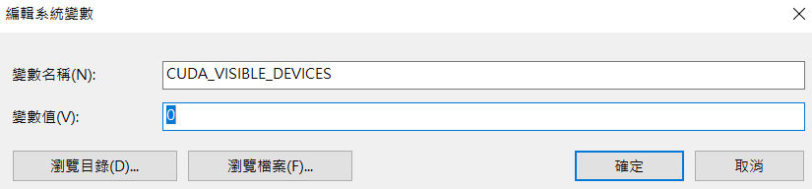

**在帶有tensorflow-gpu的虛擬環境中做以下測試，在此使用Spyder**

import os

os.environ['CUDA_VISIBLE_DEVICES'] = '-1'

import tensorflow as tf

2021-04-13 17:37:01.018073: I tensorflow/stream_executor/platform/default/dso_loader.cc:49] Successfully opened dynamic library cudart64_110.dll

tf.config.list_physical_devices('GPU')

Out[4]: []

2021-04-13 17:37:01.018073: I tensorflow/stream_executor/platform/default/dso_loader.cc:49] Successfully opened dynamic library cudart64_110.dll

2021-04-13 17:37:16.873133: I tensorflow/compiler/jit/xla_cpu_device.cc:41] Not creating XLA devices, tf_xla_enable_xla_devices not set

2021-04-13 17:37:16.879885: I tensorflow/stream_executor/platform/default/dso_loader.cc:49] Successfully opened dynamic library nvcuda.dll

2021-04-13 17:37:16.930650: E tensorflow/stream_executor/cuda/cuda_driver.cc:328] failed call to cuInit: CUDA_ERROR_NO_DEVICE: no CUDA-capable device is detected

2021-04-13 17:37:16.932783: I tensorflow/stream_executor/cuda/cuda_diagnostics.cc:169] retrieving CUDA diagnostic information for host: LAPTOP-87BJQORJ

2021-04-13 17:37:16.932857: I tensorflow/stream_executor/cuda/cuda_diagnostics.cc:176] hostname: LAPTOP-87BJQORJ

**以上可以因找不到GPU，而致使tensorflow只用CPU做計算。**

**如果要切換回可使用GPU的狀態，只要重開Spyder的console視窗後，再執行以下指令確認：**

Python 3.8.5 (default, Sep 3 2020, 21:29:08) [MSC v.1916 64 bit (AMD64)]

Type "copyright", "credits" or "license" for more information.

IPython 7.19.0 -- An enhanced Interactive Python.

import os

os.environ['CUDA_VISIBLE_DEVICES']

Out[2]: '0'

import tensorflow as tf

2021-04-13 17:45:05.044854: I tensorflow/stream_executor/platform/default/dso_loader.cc:49] Successfully opened dynamic library cudart64_110.dll

tf.config.list_physical_devices('GPU')

2021-04-13 17:45:05.044854: I tensorflow/stream_executor/platform/default/dso_loader.cc:49] Successfully opened dynamic library cudart64_110.dll

2021-04-13 17:45:09.345977: I tensorflow/compiler/jit/xla_cpu_device.cc:41] Not creating XLA devices, tf_xla_enable_xla_devices not set

2021-04-13 17:45:09.346730: I tensorflow/stream_executor/platform/default/dso_loader.cc:49] Successfully opened dynamic library nvcuda.dll

Out[4]: [PhysicalDevice(name='/physical_device:GPU:0', device_type='GPU')]

2021-04-13 17:45:05.044854: I tensorflow/stream_executor/platform/default/dso_loader.cc:49] Successfully opened dynamic library cudart64_110.dll

2021-04-13 17:45:09.345977: I tensorflow/compiler/jit/xla_cpu_device.cc:41] Not creating XLA devices, tf_xla_enable_xla_devices not set

2021-04-13 17:45:09.346730: I tensorflow/stream_executor/platform/default/dso_loader.cc:49] Successfully opened dynamic library nvcuda.dll

2021-04-13 17:45:10.748819: I tensorflow/core/common_runtime/gpu/gpu_device.cc:1720] Found device 0 with properties:

pciBusID: 0000:01:00.0 name: GeForce RTX 3070 Laptop GPU computeCapability: 8.6

coreClock: 1.29GHz coreCount: 40 deviceMemorySize: 8.00GiB deviceMemoryBandwidth: 357.69GiB/s

2021-04-13 17:45:10.749020: I tensorflow/stream_executor/platform/default/dso_loader.cc:49] Successfully opened dynamic library cudart64_110.dll

2021-04-13 17:45:10.802970: I tensorflow/stream_executor/platform/default/dso_loader.cc:49] Successfully opened dynamic library cublas64_11.dll

2021-04-13 17:45:10.803002: I tensorflow/stream_executor/platform/default/dso_loader.cc:49] Successfully opened dynamic library cublasLt64_11.dll

2021-04-13 17:45:10.826330: I tensorflow/stream_executor/platform/default/dso_loader.cc:49] Successfully opened dynamic library cufft64_10.dll

2021-04-13 17:45:10.833526: I tensorflow/stream_executor/platform/default/dso_loader.cc:49] Successfully opened dynamic library curand64_10.dll

2021-04-13 17:45:10.865629: I tensorflow/stream_executor/platform/default/dso_loader.cc:49] Successfully opened dynamic library cusolver64_10.dll

2021-04-13 17:45:10.885692: I tensorflow/stream_executor/platform/default/dso_loader.cc:49] Successfully opened dynamic library cusparse64_11.dll

2021-04-13 17:45:10.888808: I tensorflow/stream_executor/platform/default/dso_loader.cc:49] Successfully opened dynamic library cudnn64_8.dll

2021-04-13 17:45:10.889067: I tensorflow/core/common_runtime/gpu/gpu_device.cc:1862] Adding visible gpu devices: 0

**附註：若需使用多塊GPU的方式，可參考如下：**

<https://keras.io/guides/distributed_training/>

<https://faroit.com/keras-docs/2.1.2/utils/>